Roots4All Genealogical Repository Mapping Application

Software Design Specifications

Amanda Jensen

Digital Humanities 401

December 10, 2014

Introduction

The Roots4All Genealogical Repository Mapping Applcation (Roots4All) is a web-based software application based on HTML, CSS, and JavaScript. As web-based software, the application requires HTML for text markup and CSS for style. “JavaScript is the programming language of the Web.”[1] JSON, (JavaScript Object notation) would be useful in transporting “data… from a server to a webpage”[2] when working with complex data arrays. In order to process data more efficiently, an Object Oriented language is needed as well as agile programming. A waterfall style programming language could not keep up with the demands of the program after initial implementation.

The languages will display information on web-enabled devices such as laptops, tablets, mobile phones, and wearable Internet devices like the potential Cicret bracelet.[3] Further, using JavaScript and JSON would allow for all major web devices to be able to use it, whether the device ran iOS, Windows, Android, or Linux. For the purposes of this paper, the use of “program”, “application”, “app”, and “product” may be used interchangeably to mean the Roots4All software application.

1. Requirements

1.1 GOALS AND OBJECTIVES

The Roots4All Mapping Application intends to help primarily genealogists (amateur and professional along with historical researchers, not bare novices[4]) to find repositories that deal with their family’s historical location needs. These needs note that historical models in genealogical work have to be able to deal with modern realities of burned courthouses, burned censuses, natural disasters like Hurricane Katrina, disasters like the 1871 Chicago Fire, and other restrictions set by time and space.

The repository mapping application is the next step of what to do when a person has done their searches on Ancestry, FamilySearch, Fold3, or MyHeritage, and they need to know more about what is available today for the locations in question. Ancestry is now a necessary repository for searching in its own right, but does not begin to capture all of the world’s documents and data. There are lots of collections that are not online, that do not have funding for digitization of their collections, or upkeep of previous digitization efforts as technology ages. FamilySearch, even with digitizing and indexing of their entire collections from the Vault will only have around 10% of the world’s collections on their site.[5] Some websites are devoted more to place searches specifically, like USGenWeb, which lists potential repositories to an extent. Navigating the sites takes drilling up and down through levels of links and even then it is easy to get lost on those sites or for the connected links to be broken. The sites are navigable, but are not aging gracefully.

There is no one place that maps out potentially applicable repositories quickly. Libraries and archives help tremendously in searching for families, but due to collection, scope, financial resources, and the education and interests of the librarian, can only do so much. No one can be an expert in every field needed by every researcher, and that cannot realistically be expected. Not every librarian knows or wants to know everything about local history or genealogical research methodology, but they should be able to point patrons to a site beyond Ancestry that could help them easily.

Google searches do not populate family trees even with alerts set, and neither does a Google Maps search. The normal version of Google Maps when someone goes to maps.google.com, are categorized for specific keywords, but are not keyed for more than one type of repository at a time, although their API can be developed to do that. There can be development for creating a mapping system geared toward the scope of collections needed by amateur to professional genealogists. Ancestry currently has a minimal mapping option that works only with specific databases for specific keywords and only in beta form that was launched in 2013, but their scope does not include layers of mapping for social history contexts, nor does it contains any ethnographic data, both of which could be parts of Roots4All.

An average user of Roots4All should be able to tap or click on the app on any given device, tap or click on the search area, and either type in an applicable address, or tap on a general town, county, or other level of land boundary and find repositories that hold genealogical collections within the area easily. All results would be tagged in a list complete with addresses, websites, and phone numbers for contact. Should a person be onsite, the same search would bring up GPS including driving or walking directions for making the fastest trip or best time use between repositories if someone only had a day or limited times to be there, maybe including operation hours to assist with trip planning.

A frequent argument between government and libraries funding them is need of proof of legitimacy, and requires the self-promotion needs of the libraries if the library does not have a huge patron base. A listing on Roots4All is instant free advertising to those repositories that otherwise would not be known. Roots4All fills a need for a fast, sleek method for finding the right repository fast, assuming that someone has already tried the most commonly used sites to look up immediate ancestors.

* 1. Statement of Scope
     1. Essential, Initial

Major inputs for Roots4All would be basic identifying data such as that found in the Yellow Pages including organization name, address (mailing and/or physical), telephone numbers, websites, and email addresses as applicable. Those details would be mapped using a matrix such as Google Fusion Tables or GeoRSS layers from aggregate mapping company APIs like Google Maps. Using scripts, the APIs could be searched and pull back local through to national collection information (e.g. National Archives Great Lakes Branch, 7358 S. Pulaski Road, Chicago, IL 60629-5898, 773-948-9001, Fax: 773-948-9050, Email: [chicago.archives@nara.gov](mailto:chicago.archives@nara.gov), Website: www.archives.gov/great-lakes/)[6] for modern genealogical collection repositories such as churches, schools, newspapers, libraries, archives, funeral homes, cemeteries, and government offices.

If a group (genealogical, historical society, or independent library or individual with a large collection) was not initially part of the input, an easy form could include them in update would help with the goals of the application. Processing would be done using a LAMP base server system. Output could also include a printed list of repositories that would be on Roots4All for a given area.

Both of these the Google Maps Places Library with the ability for smaller genealogical and historical societies to join the Google Maps API. Another potential starting point for running Google Places would be to compare it with the Yellow Pages API[7] start with Chicago as test subject. The app would be built on Google Maps JavaScript API: Google Places Library[8] using scripts for and allow for overlaying historical information easily with heat maps, incorporating coded Fusion tables for the different repository types available in a given area.

* + 1. DESIREABLE

Ethno-graphic population heat maps that layer race, ethnicity, and religion on modern and historical location maps using University of Minnesota National Historical Graphic Information Systems (NHGIS) data.[9] Built on Google Maps JavaScript API Heatmap layer[10], a GeoJSON layer, and styling the map to reflect differences between layers, the NHGIS information would display Population data (Race, Ethnicity, and Origins; Military Service, and Slavery), and Other data (Religion, Schools, Libraries, Newspapers and Periodicals) using different colors or textures (hypothetically: green, purple, dashed lines, etc.) for different parameters. This level would not only use Dicennial Census data but also the 1906, 1916, 1926, 1936 Censuses of Religious Bodies and the 1952 Survey of Churches and Church Membership in addition to the 1925 Special Census of Detroit and 1934 Special census of Chicago.

* + 1. FUTURE
       1. GED-COM uploads for list of repositories of use to the largest amount of ancestors based on place. GED-COM scanning for repositories for direct-line ancestors or ancestors with a particular surname. Multiple reports available, but would need further knowledge of underlying GEDCOM and GEDCOMX programming language to implement.
       2. .Historical boundary shifts as a map layer. This may need use of the Atlas of Historical County Boundary Changes which includes meta files.[11]
  1. CONTEXTUAL EXAMPLES
     1. Map Features in GEDCOM personal genealogical database software
        1. Family TreeMaker[12] offers maps in beta format only. As an Ancestry product, this would make sense that they are trying to implement new site features to carry over into their utility tools. Current versions of Family TreeMaker do not have historical maps included.
        2. RootsMagic 7[13] now contains historical county changes for the US, UK, Canada, and Australia. This may change part of the scope of “Future” concepts for Roots4All’s app, but Roots4All could focus more on other locations worldwide that are not covered by the WASP-centric feature.
        3. Legacy Family Tree[14]- includes typical mapping feature available in many places of tracing a family’s migrations through time.
     2. Map Layer Features Effect
        1. Padmapper[15]: Although the site is used for finding apartments, when adding the layers of walkability, the El lines, and other features, the functionality is closer to what would be useful for Roots4All.
        2. Hypercities[16]: When reviewing historical mapping options, this is a slick example of major cities in time.

1.4 CONSTRAINTS

Although the easiest ways to come up with the repository lists would be to enlist partners like the Federation of Genealogical Societies[17], the Genealogist’s Address Book[18], of societies of funeral homes, using the Yellow Pages and Google Maps may bypass a need for their input, or relinquishing control over the product in light of data. Partnerships with these groups or authors (in the case of Ms. Bentley) has not yet been approached.

1. DATA DESIGN

2.1 GLOBAL DATA STRUCTURES

The Google Maps Library would have to be available during every search and be accessible at every layer level when running the application.

2.2 INTERNAL DATA STRUCTURES

Historical map layers would have to work in tandem with each other to come up with fluid movement on the app UI. In addition, outside of the Map Library, all JavaScript API layers would function at this level.

2.3 TEMPORARY DATA STRUCTURES

2.3.1. The user name and password database (populated mainly for statistics and contact purposes) should be running in the background, but not actively sent for retrieval of information outside of using for log in/log out and customer service needs.

2.3.2. Any historic gradation searches would be stored at this level.

2.3.3. Printing preferences would also be a temporary data structure.

2.4 DATABASE USAGE

2.4.1 The entire site is run on layers of database searches mapped and meshed together as the user prefers in layers of matrices. This would be how the application runs on average per user.

2.4.2. Saving a search: Not every user will want to re-run the same scenario, or may need to save a particular search run for research. The save function would allow for a particular search query to be saved along with the meshed or mapped layers.

2.4.3 Universal Searches: As part of future uses of the app, uploading GEDCOM information for massive searches would be the next incarnation. Searching one place at a time is useful when searching on a particular line or person, but a when crunching big data points (such as those for 10,000 people and a minimum of 30,000 potential locations, although likely far less based on likelihood of groups of people staying near a geographic central point for perhaps one generation), then the app needs server space and features to run searches automatically. Big data trends for families in case studies is something that begs for exploration should the tools be available to quickly and easily easy for the user) crunch the places along with their historical and demographic markers.

This could be accomplished using the FamilySearch login portal, granting access to basic genealogical information to outside companies while still keeping sensitive API behind a firewall. This process is currently in practice with TreeSeek, KinPoint, and other new (as of the last two years) genealogical analytical programs.

1. ARCHITECTURAL DESIGN

The architectural design models using a UML chart. Processes move from the user to the software and through various search possibilities and their back-end counter-parts, finally ending with either Saving Search parameters or Printing results as needed.

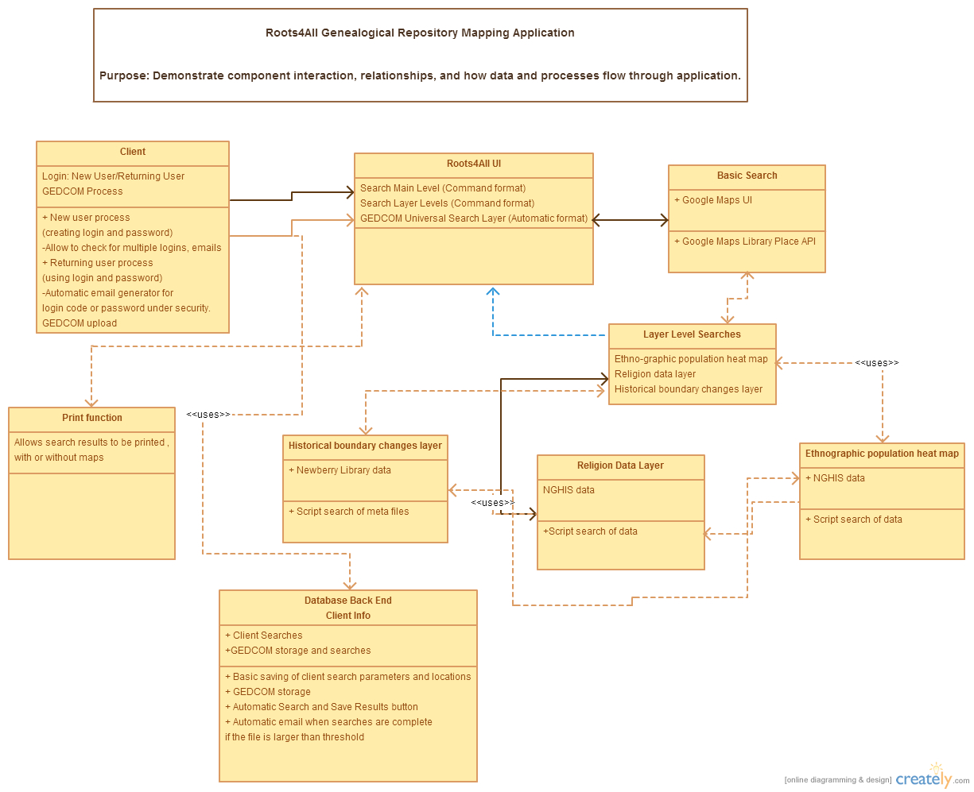[19]

See attached pdf, Roots4All UML PDF.pdf for closer view of design.

1. COMPONENT-LEVEL DESIGN
   1. **User Portal**: User and Client are synonymous.
      1. Login Area

4.1.1.1PROCESSING NARRATIVE: Allows user to interact with Roots4All from login to Saving Searches to Uploading GEDCOMs to any other aspects of their personal experience with the software. It is essentially a “My Account” area.

* + - 1. COMPONENT INTERFACE:

4.1.1.2.1 Login: User begins by going to the site, and then either logging in (if they have been to the site previously) or registering as a new user. Simple name, email, and password, and clicking yes to the user license agreements.

4.1.1.2.2Returning Login: Similar to the initial login, but allowing for cookies to be enabled if the person does not want to have to log in every time they come to the site.

4.1.1.2.3Saving Searches: A small icon that would look like a former floppy or similar understood icon to bring up a small form for saving a particular search under a particular name.

4.1.1.3 COMPONENT PROCESSING: Using Javascript, the users would begin entering their information into a form which would push an entry to an array. For returning users, the commands would search the array and return their permission to continue to the next step in processing, which would return the UI to the user.

* + 1. GEDCOM INTERACTIONS (Part of the database backend)

4.1.2.1 PROCESSING NARRATIVE: Used for helping automate the software experience. Likely for power users and for those who prefer the efficiency of running their database through the system at once rather than checking individual addresses.

4.1.2.2 COMPONENT INTERFACE:

4.1.2.2.1Option 1: Direct upload of GEDCOM to the Site. Choose Universal search GEDCOM and the results return.

4.1.2.2.2Option 2: Using a login screen from family search, the GEDCOM information moves through the program, executing a similar search to the direct upload of a GEDCOM file. GEDCOM information does not have to be stored on Roots4All’s server in this scenario.

* + - 1. COMPONENT PROCESSING: Using either the Family Search login, or direct upload of the GEDCOM file, the site would need an “automatic search” mode for at least the base layer. Potential for using all layers search possible, also.

4.1.3 Printing: If wanted, there would be an icon that looks similar to a printer near to the Save Function that allows for Printing a given search query.

* 1. **Roots4All UI**
     1. PROCESSING NARRATIVE: Base layer of the program and heart of the app. Place for entering search queries, and seeing results.
     2. COMPONENT INTERFACE: Input would be a searched address, e.g. 1234 Anywhere St. Anywhere, VA. After the query is made, the results would come back in options of multiples (everything), or in particular orders such as only cemeteries, churches, newspapers, governments, etc. laid out on the map.
     3. COMPONENT PROCESSING: The query would go use a search all parameter on the base layer, resulting in everything coded to an ID that corresponded to key words in the Google algorithms. Google Maps Fusion Table would be the base layer, using perhaps color coding for different types of repositories.
  2. **Layer level searches**
     1. ETHNOgraphic population heat map

4.3.1.1 PROCESSING NARRATIVE: This layer is meant for checking on the social aspects of any given era, specifically when in time an ancestor lived in a particular place.

* + - 1. COMPONENT INTERFACE: The layer would need check box options for the various census years, to remove or include them which when checked would add graduated heat map colors to the areas around the address in question.

4.3.1.3 COMPONENT PROCESSING: The query would use a Google Maps JavaScript API Heatmap layer for displaying NHGIS information searches of the ethnography data, resulting in everything coded to an ID that corresponded to key words in the Google algorithms.

4.3.2 Religion Data layer

4.3.2.1 PROCESSING NARRATIVE: As important as knowing what the surrounding churches were for a given time and what is currently available in an area, the religious preferences during special census schedules could help in identifying where to look for church records.

* + - 1. COMPONENT INTERFACE: similar to the heat map structure, but of a different graphical texture, the religious map would require initial input, and then checking on boxes similar to the super-secret features available on Padmapper.

4.3.2.3 COMPONENT PROCESSING: The query would use a Google Maps JavaScript API GeoJSON layer for displaying NHGIS information searches of the religious data, resulting in everything coded to an ID that corresponded to key words in the Google algorithms.

* + 1. historical boundary change layer
       1. PROCESSING NARRATIVE: Without historic boundary changes, most of the ethnographic and religious preferences may become mute. This layer helps bring better context to the areas in question. As this layer is already a new feature on at least one personal genealogical database program, (RootsMagic 7) its inclusion may be more to complement users who are not avid genealogists but choose to use the software for other historical and social research purposes.
       2. COMPONENT INTERFACE: Upon entering an address, boundary lines for the area would appear color-coded for single borders, years, or over-lapping lines.

4.3.3.3 COMPONENT PROCESSING: The query would use a Google Maps JavaScript API KML layer for displaying NHGIS information searches of the historical data, resulting in everything coded to an ID that corresponded to key words in the Google algorithms.

1. USER INTERFACE Design:

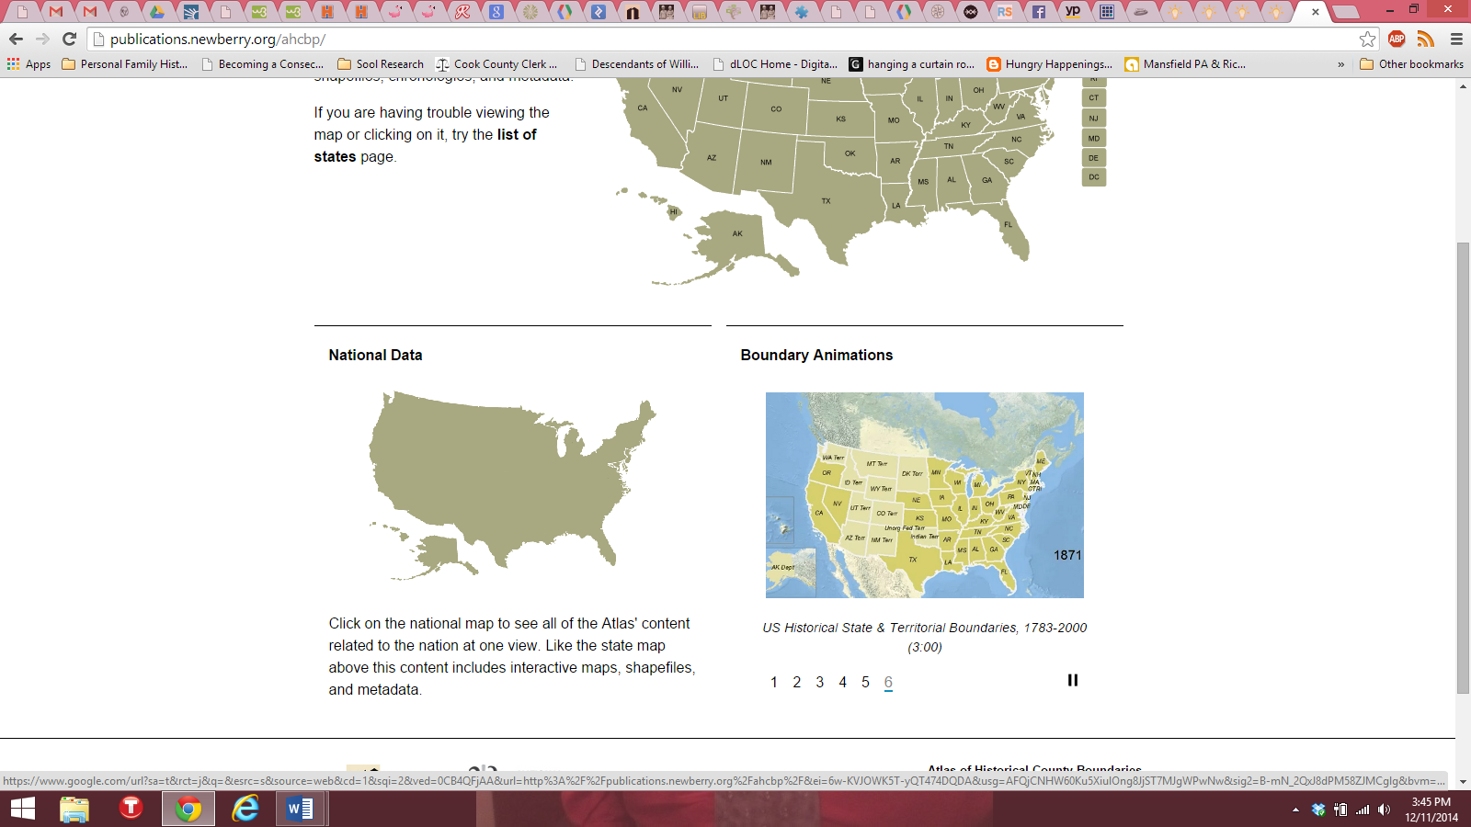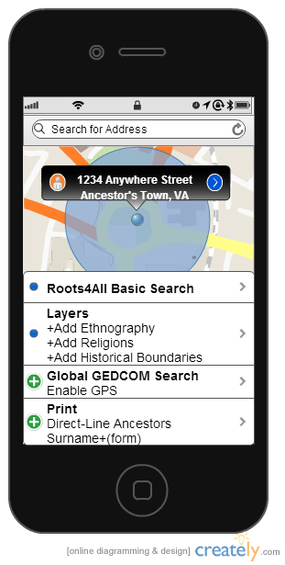This Mockup is the closest that I could get to the design of Root4All. If taking this, and adding some of the Padmapper[20] utility actions into account, adding the Atlas of Historical Boundary Changes mockup[21] as an example of the historical mapping boundary changes, then a designer could begin to get a feel for the dynamic scope of Roots4All as a humanities tool.

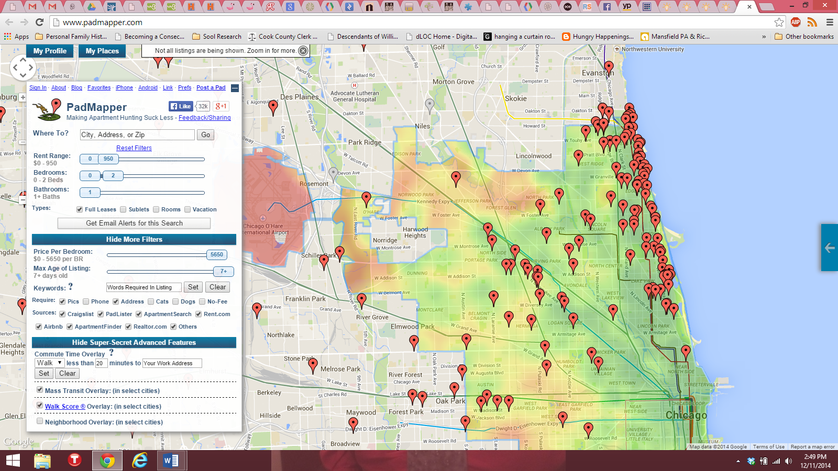

^Mockup of historical boundary overlaps

<Basic UI Mockup using an iPhone base, map background, overlay, identifying bubble, and table menu.

Model of heatmap and demographic capabilities when using layers on a basic Google map with chosen locations.

6.0 restrictions, limitations, and constraints

The first draft of this design contained a plan to build a comprehensive Chicago Cemeteries site as that did not exist in a modern, comprehensive format. As of Memorial Day 2014 a Graveyards.com was re-launched and now its creator, Matt Hucke, may already have enough of the concept for the cemetery portion on his site to keep me from pursuing Chicago Cemeteries as the primary target to get started on that topic specifically as the initial portion of the Roots4All design. Although Hucke’s site does not presently flesh out details about the Cook County cemeteries at this time,[22] his two books[23] on the topic of Cook County Cemeteries tend to intimate that may be part of his intention.

Mr. Hucke has also included a map of all of the cemeteries on his list. I do not intend to copy Mr. Hucke’s visual concepts as my intention is eventually for scalability beyond Chicago and Illinois with cemeteries as one part of the whole. As part of his blog,[24] Hucke writes of his headaches and trials in upgrading his site from a web format acceptable in 1996 through various incarnations to one that contains best practices work for 2014.[25]

Time is the biggest restriction for the app. Genealogical technology changes on a daily basis and shifts in strategy for companies change their focus quickly, or else they go under. Another large restriction is money. Presently, there is one developer for the project, and the developer likely needs a Kickstarter campaign or a grant allowance to get the project moving so that this could become full-time work paying the developer’s expenses as the development progressed. The developer currently owns the name, Roots4All, as a business name in the State of Illinois, but is considering changing her business model to a non-profit or not-for-profit base so as to be able to compete for grants and to allow for tax-deductible donations for the software program in addition to other ends of the non-profit such as being paid for charitable research work for those who cannot afford standard professional genealogical research rates.

Aspects of data control such as server space and security measures would be necessary to implement for user comfort. As all of the data used for this app is free and open source outside of the user’s login, password, and GEDCOM information, and should a user choose to login to their FamilySearch account, the login creates permission to use their information from the site for analysis purposes regarding the map searching structures. Using the FamilySearch login needs further consideration and information before proceeding with that avenue. Otherwise, users could potentially upload GEDCOM information directly with a user agreement that the GEDCOM information would only be used for the purposes of the application and that any other use of the information would be done with the GEDCOM owner’s full knowledge and consent if ever needed to be used, which is extremely unlikely.

Otherwise, the main person who could likely have reservations is Elizabeth Petty Bentley, as her Genealogist’s Address Book may be superceded by the Roots4All app. Considerations about whether or not to partner with her, or simply compete are both under consideration as the application overlaps, but also does some different things than her address book.

7.0 testing

All applications would need testing initially via automated systems for testing on all operating systems. From there, the alpha test would need white box and black box testing for testing the internal structures and functionality of the system. Without both tests, the application should not go to a beta launch. Previous to a beta launch, white hack hackers would need to test the system as thoroughly as possible. This would also be another place where funds were needed for paying to find holes in the system, security breaches, and places where viruses could creep in. Back doors should not be open beyond Admin-level users.

8.0 Appendix: CONCEPTUAL IDEA

The idea for Roots4All came in 2011 when Mrs. Jensen moved to a new city, Chicago, and could not find any one place that listed the major genealogical repositories in the area online. Although the Newberry was a world-renown library, and the developer was familiar with the idea of using the local LDS Family History Center due to prior use in other locations, the on-ground knowledge of local cemeteries, specific genealogical repositories, and similar pertinent information was not readily available for use online. In 2011, why was this not available? Why could not someone move from another location and find that specific information quickly and easily? The lack of easily-available information was disturbing and rather dumb-founding. During a final exam in library school that fall, Jensen came up with the idea for a multi-layered map that could allow not only repositories to come up instantly, but also to layer other needs of the public historian and the genealogist together for mutual benefit.

1. W3 Schools. “Home,” *JavaScript Tutorial*. <http://www.w3schools.com/js/default.asp>. Accessed December 10, 2014.
2. W3Schools. “What is JSON?” *JavaScript JSON*. <http://www.w3schools.com/js/js_json.asp>. Accessed December 10, 2014.
3. *Cicret App & Bracelet*. <https://www.facebook.com/CicretAppandBracelet>. Accessed November 2014. Should this bracelet get past proof of concept, it would be a viable extension of the mobile interface.
4. Novices need to review home sources first and to gather available information from living relatives before using Roots4All. Although a user could simply enter their home address into the search bar to find local repositories, the more-powerful use of the application beyond novelty is that of finding new or different repositories that could have the needed data to continue breaking down the brick walls (stopping points, dead ends and research problems) that keep researchers from moving through their research.
5. FamilySearch, formerly known as the the Utah Genealogical Society, has been collecting record worldwide since 1894, and microfilming documents of import to genealogical research since 1938. The statistic regarding the collections of the Vault was given during an undergraduate historical research class by Dr. Gerald Haslam between the years of 2004 and 2006. Although FamilySearch continues to digitize collections worldwide, for the purposes of this paper, the number will stand.
6. National Archives brochure: <http://www.archives.gov/chicago/brochure.pdf>. Accessed December 11, 2014.
7. YP Publisher Center. <https://publisher.yp.com/> 2014. Accessed December 10, 2014.
8. Google Developers, “Which API do I need?” Google Maps API. Last updated December 10, 2014. <https://developers.google.com/maps/documentation/api-picker>.
9. Minnesota Population Center. National Historical Geographic Information System: Version 2.0. Minneapolis, MN: University of Minnesota 2011. [http://www.nhgis.org](http://www.nhgis.org/).
10. Google Developers, “Which API do I need?” Google Maps API. Last updated December 10, 2014. <https://developers.google.com/maps/documentation/api-picker>.
11. Newberry Library, “Atlas of Historical County Boundary Changes,” Newberry Library. <http://publications.newberry.org/ahcbp/> Accessed December 11, 2014.
12. Ancestry, Family TreeMaker. <http://www.familytreemaker.com>. Accessed December 10, 2014.
13. Rootsmagic, Inc. RootsMagic Features. <http://www.rootsmagic.com/rootsmagic/features.aspx>. Accessed December 11, 2014.
14. “Compare Legacy”, Legacy Family Tree. <http://www.legacyfamilytree.com/Compare.asp>. Accessed December 10, 2014.
15. “Show More Fileters”, “Super-Secret Advanced Features.” Padmapper.com [www.padmapper.com](http://www.padmapper.com). Accessed November 2014.
16. Hypercities. <http://hypercities.ats.ucla.edu/> Accessed November 2014.
17. Federation of Genealogical Societies. ”Find a Society” <http://www.fgs.org/cstm_societyHall.php> Accessed November 2014.
18. Elizabeth Petty Bentley, *The Genealogist’s Address Book*. (Baltimore, MD: Genealogical Publishing Company, 2009).
19. Made using Creately.com. December 11, 2014.
20. Made using Creately.com. December 11, 2014.
21. Atlas of Historical County Boundary Changes. http://publications.newberry.org/ahcbp/. Accessed December 11, 2014.
22. Matt Hucke, “Cemeteries and Graveyards in Cook County, Illinois”, Graveyards.com. <http://graveyards.com/Illinois/Cook/list> 2014. Accessed December 10, 2014.
23. Matt Hucke and Ursula Bielski, *Graveyards of Chicago: The People, History, Art, and Lore of Cook County Cemeteries*. (Chicago: Lake Claremont Press) 1999, 1st edition, and 2013, 2nd edition.
24. Matt Hucke. “Blog”, Graveyards.com <http://graveyards.com/blog>. 2014. Accessed December 10, 2014.

    Bibliography

    Ancestry, Family TreeMaker. <http://www.familytreemaker.com>. Accessed December 10, 2014.

    Bentley, Elizabeth Petty. *The Genealogist’s Address Book*. (Baltimore, MD: Genealogical Publishing Company, 2009).

    *Cicret App & Bracelet*. <https://www.facebook.com/CicretAppandBracelet>. Accessed November 2014.

    “Compare Legacy”, Legacy Family Tree. <http://www.legacyfamilytree.com/Compare.asp>. Accessed December 10, 2014.

    Creately.com. Accessed December 11, 2014.

    Federation of Genealogical Societies. ”Find a Society” <http://www.fgs.org/cstm_societyHall.php> Accessed November 2014.

    Google Developers, “Which API do I need?” Google Maps API. Last updated December 10, 2014. <https://developers.google.com/maps/documentation/api-picker>.

    Hucke. Matt. “Blog”, Graveyards.com <http://graveyards.com/blog>. 2014. Accessed December 10, 2014.

    Hucke, Matt. “Cemeteries and Graveyards in Cook County, Illinois”, Graveyards.com. <http://graveyards.com/Illinois/Cook/list> 2014. Accessed December 10, 2014.

    Hucke, Matt and Ursula Bielski, *Graveyards of Chicago: The People, History, Art, and Lore of Cook County Cemeteries*. (Chicago: Lake Claremont Press) 1999, 1st edition, and 2013, 2nd edition.

    Hypercities. <http://hypercities.ats.ucla.edu/> Accessed November 2014.

    Minnesota Population Center. National Historical Geographic Information System: Version 2.0. Minneapolis, MN: University of Minnesota 2011. [http://www.nhgis.org](http://www.nhgis.org/).

    National Archives brochure: <http://www.archives.gov/chicago/brochure.pdf>. Accessed December 11, 2014.

    Newberry Library, “Atlas of Historical County Boundary Changes,” Newberry Library. <http://publications.newberry.org/ahcbp/> Accessed December 11, 2014.

    Rootsmagic, Inc. “RootsMagic Features.” <http://www.rootsmagic.com/rootsmagic/features.aspx>. Accessed December 11, 2014.

    “Show More Filters”, “Super-Secret Advanced Features.” Padmapper.com [www.padmapper.com](http://www.padmapper.com). Accessed November 2014.

    W3 Schools. “Home,” *JavaScript Tutorial*. <http://www.w3schools.com/js/default.asp>. Accessed December 10, 2014.

    W3Schools. “What is JSON?” *JavaScript JSON*. <http://www.w3schools.com/js/js_json.asp>. Accessed December 10, 2014.

    YP Publisher Center. <https://publisher.yp.com/> 2014. Accessed December 10, 2014.
25. I am also attempting to work with a Chicago researcher, Barry Fleig, who recently uploaded the Chicago City Cemetery database regarding Dunning, as another project for him is a comprehensive Chicago Cemeteries page, but that will need to wait for consultation with Mr. Fleig after reviewing Mr. Hucke’s work. They might collaborate. All considerations are currently under consideration.